# Team Swasthya: World Innovation Day

**Global Conditions:**

**Mortality due to Covid**

**Mortality due to non-Communicable Diseases**

**Number of People over 65 in the world**

**Number of People who don’t have adequate access to healthcare**

**Number of Single Person Dwelling of people over 50**

**Coronavirus Cases in India (COVID-19)**

**(**[**https://www.statista.com/topics/6135/coronavirus-covid-19-outbreak-in-india/**](https://www.statista.com/topics/6135/coronavirus-covid-19-outbreak-in-india/)**)**

It all started in January 2020 when three Indian students travelled to Kerala from Wuhan in China (epicenter of coronavirus) and tested positive. Since then, the infections increased rapidly from March until today.

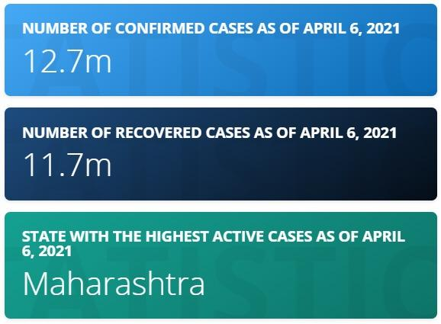

**Overview of COVID-19 in India: (**[**https://www.statista.com/statistics/1111149/india-opinion-on-coronavirus-fears-and-concerns/**](https://www.statista.com/statistics/1111149/india-opinion-on-coronavirus-fears-and-concerns/)**)**

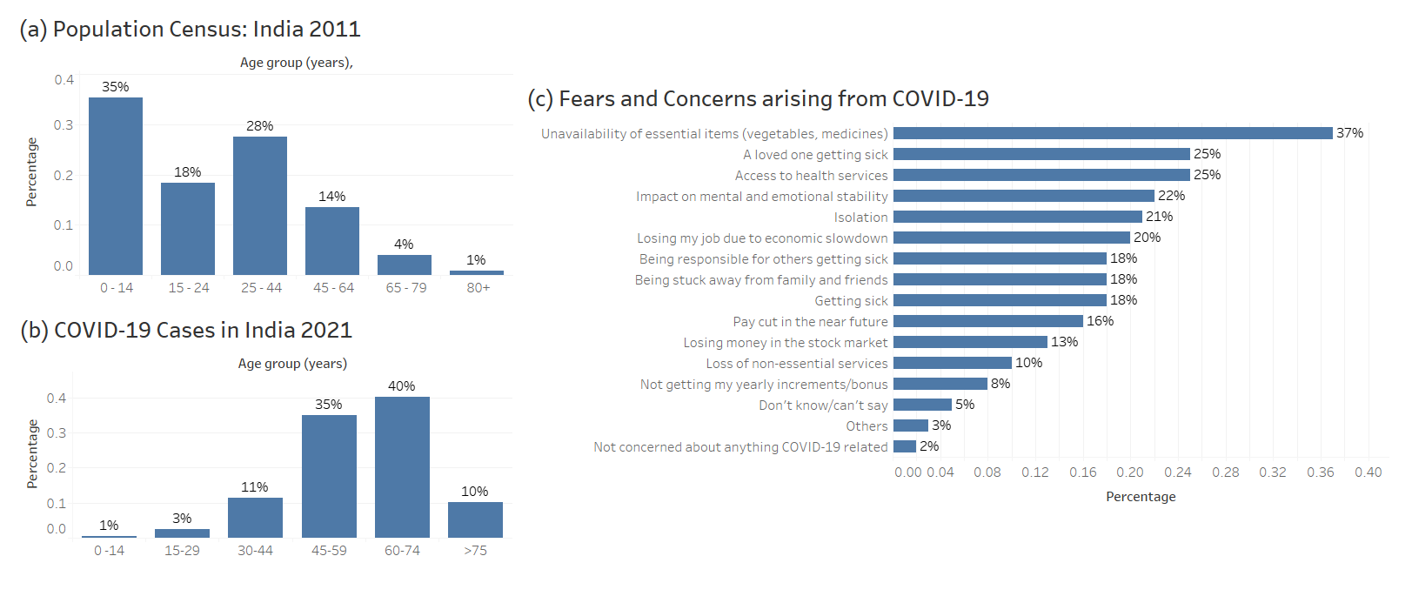

Population census (2011) and COVID-19 cases (2021) are shown above.

**Observations:**

1. 81% of India’s population fall in the age group below 44.
2. 85% of COVID-19 cases in India fall in the age group 45 and above
3. Top 3 fears are related to unavailability of essential items (vegetables, medicines), a loved one getting sick, access to health services and impact on mental and emotional stability

**Why do we choose this approach?**

1. The 2011 India Census shows that 81% of the population falls below 44 years of age.
2. COVID-19 data from various sources such as John Hopkins State University notifies that 85% of the COVID-19 cases fall in the age group 45 and above.
3. Our app ‘Local Angels’ makes use of the Human to Human (H2H) approach. Based on the points 1 and 2 above, it is evident that 85% of the elderly (45+) people will need help/assistance and they cannot travel outside based on the COVID-19 protocol.
4. Since 81% of the younger population (below 44) is least affected by COVID-19, they can serve as volunteers and help the elderly people. Hence Local Angels have a great potential to serve the needy people.

**How will it be a success?**

A survey among 1000 adult online population between April 7 to 10, 2021 and the results are as below:

1. 37% of the adults had a fear that they would not be available to access the essential items like vegetables and medicines.
2. 25% of the respondents were concerned about their loved one falling sick and that they won't have any access to health services.

In India, most of the monetary transactions require hard cash and hence people cannot pay online. They would need to go to Banks/ ATMs to cash out the money. People cannot leave their home when they are sick. As a result, they cannot purchase essential items like vegetables and medicine as shown in the data above.

25% of the people think that they cannot access health services which in turns lead to anxiety and causes mental and emotional stability.

Our main focus of H2H is to connect volunteers to the people in need which can help to solve the major chunk of the fear arising due to the pandemic.

We aim to cater the needs of the people in need as well as help them emotionally by connecting them with local volunteers and thus want to give a strong message that “People need People”.

***Inconvenience:***

1. People above 45 are most affected by Covid-19 in India. The children of many families live away from parents on onset of job purposes, educational purposes, etc. As a result, many people in this age bracket stay alone.
2. As COVID-19 is a communicable disease, these people cannot go outside as they may act as active carriers and spread the virus.
3. They cannot access the basic needs such as groceries, medicines, cash from banks, day to day services, etc.
4. People cannot meet/talk with their loved ones and hence the mental health deteriorates leading to anxiety and loneliness.

***Solution:***

1. We intend to make an app which is H2H.
2. People can download the app and can either log in their problems/issues or be a volunteer and help the people around who cannot access the outside world.
3. As seen from above, since 81% of the population is below 44 and less prone to COVID-19, they can serve as volunteers and help the people in need.
4. We expect the app (Local Angels) to be a massive hit as the volunteers get reward/good will points as they serve more and more people.
5. Also, a volunteer can act as a user to log problems if the need arises and vice-versa.